Results from Prior NSF Support:
NSF-MRI-ATM-0320540, “1.6 Meter Solar Telescope in Big Bear - The New Solar Telescope (NST)”, $1,967,193 plus $705,523 match by NJIT (8/03-7/07)
Phil Goode, PI

The NST is discussed in some detail in Section A.2 of the proposal, and its construction was supported by an MRI grant (ATM-0320540). So the discussion here will be brief. The NST is an off-axis Gregorian system consisting of a parabolic primary, prime focus field stop and heat reflector (heat-stop), elliptical secondary and diagonal flats, as shown in Figures 2 and 3 in Section A.2. The NST obtained first light images in January 2009 and one is show here of the Sun’s granular field, which is all that is available because the Sun continues to be in a state of very low activity. The individual granules are sharper than any images we ever obtained with the 0.6 m telescope. The image shown just below was obtained at the Gregorian focus of the
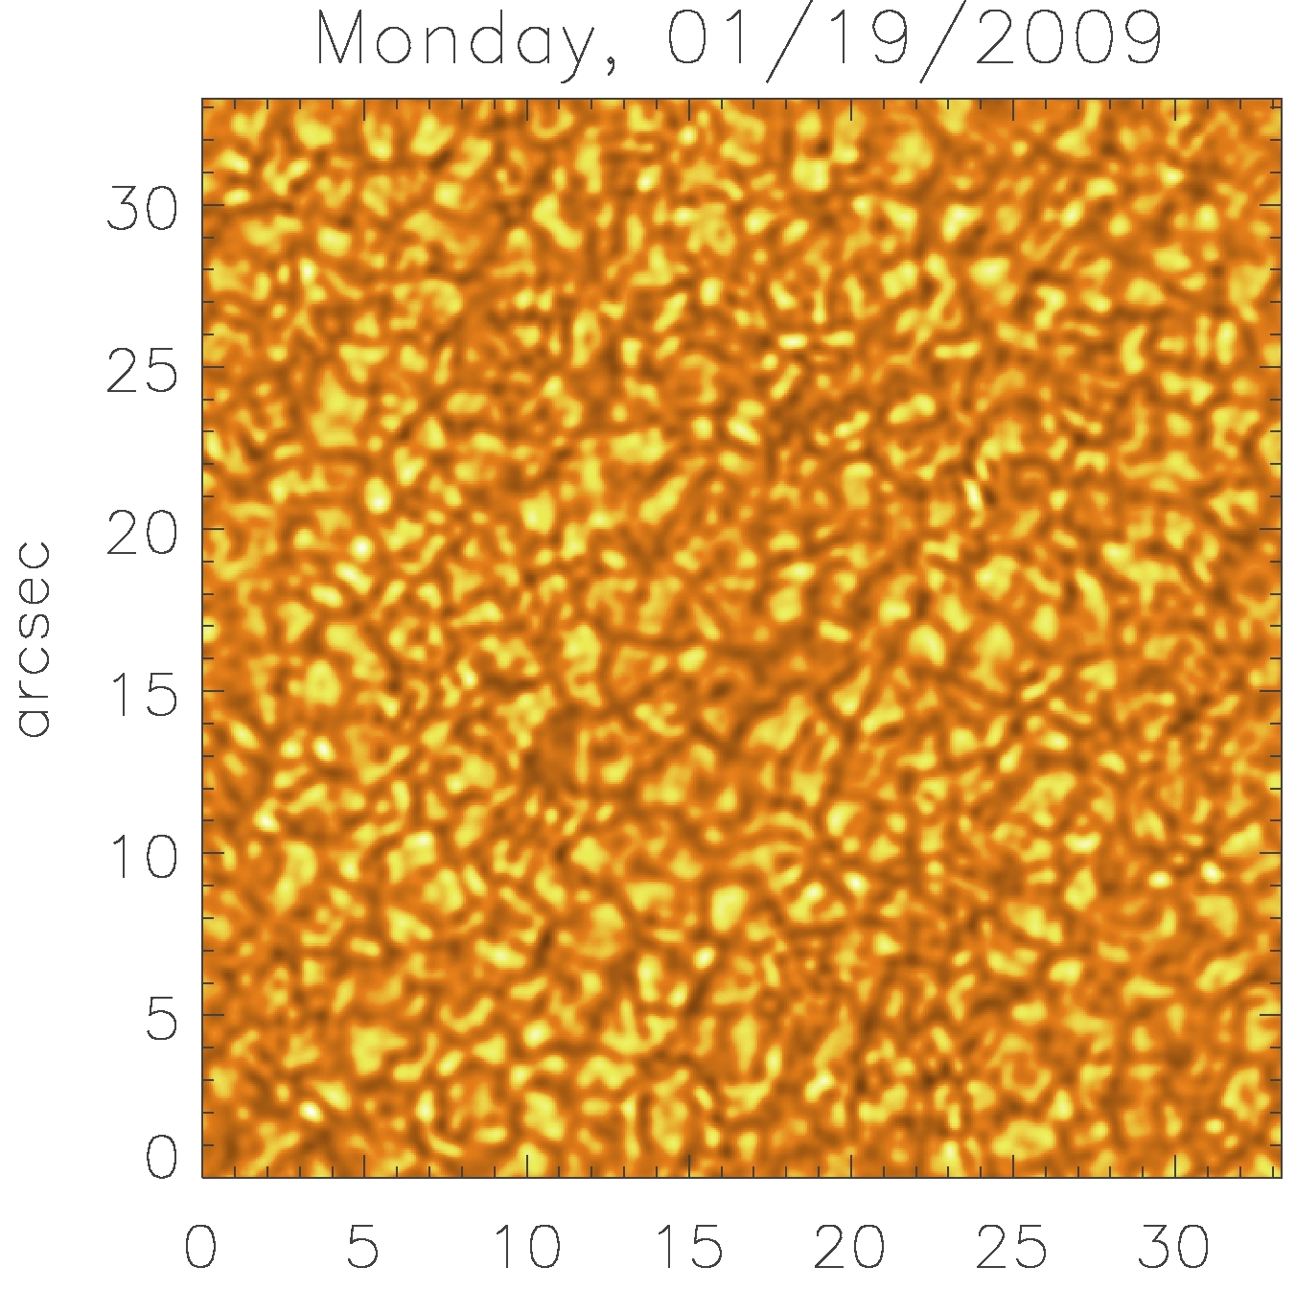
telescope without correction from adaptive optics. This kind of light feed is what will feed CIRS. Thus, we emphasize that we have the light feed required for CIRS, and would be ready to proceed with the project almost immediately. At present, telescope alignment continues and light will be fed Summer of 2009 to the Coude Lab, which is beneath the telescope floor. There images will be corrected by our existing AO system, and fed to our imaging polarimeters – beginning in the NIR. Our observations in the NIR are imaging and cut-off at 1.7 microns, which emphasizes the need for the CIRS. The figure to the left shows a visible light, broad-band image with a FOV of about 30 by 30 arcseconds. This image is not in the main body of the proposal because it was analyzed after the proposal deadline. The MRI grant (ATM-0320540) that was key in building the 1.6 m NST resulted in several technical publications and will soon lead to many scientific papers.

Publications under ATM-MRI ATM-0320540

Goode, P. R.; Denker, C. J.; Didkovsky, L. I., Kuhn, J. R. and Wang, H., 2003, 1.6 M Solar Telescope in Big Bear – The NST, JKAS, 36, 125.

Denker, C.; Marquette, W. H.; Varsik, J.; Wang, H.; Goode, P. R.; Moretto, G.; Kuhn, J.; Coulter, R., 2005, The New Solar Telescope at Big Bear Solar Observatory, AGU General Assembly Presentation.

Didkovsky, Leonid V.; Dolgushyn, Alexander; Marquette, William; Nenow, Jeff; Varsik, John; Goode, Philip R.; Hegwer, Steven L.; Ren, Deqing; Fletcher, Steve; Richards, Kit; Rimmele, Thomas; Denker, Carsten J.; Wang, Haimin, 2003, High-order adaptive optical system for Big Bear Solar Observatory, SPIE, p. 630, vol. 4853, (2003).

Cao, Wenda; Denker, Carsten J.; Wang, Haimin; Ma, J.; Qu, M.;Wang, Jinshan; Goode, Philip R., 2004, Characteristic evaluation of a near-infrared Fabry-Perot filter for the InfraRed Imaging Magnetograph (IRIM), SPIE, p. 307, vol. 5171.

The NST will provide data for many PhD students, but none were directly involved in the project. PhD students, like Kwansu Ahn and Sung-Hong Park, whose works are discussed in the third part of this addendum, will be among the first beneficiaries of the NST. Building and testing the NST has been a significant engineering effort.

Results from Prior NSF Support:
NSF-AST0607295: "The Solar Oxygen Crisis" $192,808 (08/06--07/09)
T.R. Ayres, PI
This project currently is in progress. The main results so far have been published in two recent refereed papers:
Ayres, T.R., 2008, Solar Forbidden Oxygen, Revisited, ApJ, 686, 731.
E. Caffau, H. Ludwig, M. Steffen, T. Ayres, P. Bonifacio, R. Cayrel, B. Freytag, B. Plez, 2006, The Photospheric Solar Oxygen Project. I. Analysis of Atomic Lines and Influence of Atmospheric Models, A&A, 488, 1031
A third paper concerning the solar carbon abundance (with E. Caffau first author) is in preparation. An additional report was published in the proceedings of the 14th Cambridge Workshop on Cool Stars, Stellar Systems, and the Sun, held in Pasadena in fall 2006.
The first paper represents an attempt to revisit the formation of a key forbidden oxygen absorption line in the solar spectrum (630 nm), whose analysis seven years ago by a group at the University of Texas suggested that the solar oxygen abundance was anomalously low. Their study was based on application of 3D convection models to the simulation of the oxygen line, which unfortunately is blended with a Ni I absorption of similar strength. Surprisingly, the PI was unable to reproduce the authors' results utilizing a new series of 3D photospheric models, and instead obtained an oxygen abundance close to what is favored by helioseismology (The earlier proposed low oxygen abundance had been a source of much concern in the helioseismology community. Their models of the solar interior, which previously had achieved spectacular agreement with surface measurements of p-mode frequencies, fell apart with the new low O abundance.) The parallel study by Caffau and collaborators, including the PI, examined the formation of literally every accessible O I line in the visible and near-IR spectrum of the Sun. We again found evidence that the oxygen abundance was higher than in the original Texas study. An even newer examination, now of the carbon abundance, again concludes that the earlier reports of very low solar CNO abundances cannot be confirmed, but rather the new results are more in line with the metallicity favored by helioseismology. (A similar conclusion was reached in a study the PI did for the Cool Stars Workshop in fall 2006, which examined the formation of mid-IR carbon monoxide absorptions with the new generation of photospheric 3D models.) Additional work in these areas is in progress.
A second part of the NSF-supported project, and most relevant to the present MRI proposal, was to undertake observational work with a new IR camera being commissioned on the McMath-Pierce solar telescope on Kitt Peak. The state-of-the-art Aladdin detector replaces a very outdated chip that has been in use for more than a decade. The new camera has a much larger format, is much more sensitive, and is cosmetically very clean. It is used in conjunction with the large vertical spectrograph in the thermal IR (4660 nm) to record spatially resolved absorptions of CO. In the past year, the PI has had three runs with the new camera, most recently in January 2009, and an additional week is scheduled in late April. The initial two runs were mainly devoted to engineering tests of the new detector, coupled with an upgraded adaptive optics system, and a new software approach to mechanical scanning of the solar image. The conditions were not particularly favorable during these runs, but the experience with shaking down the new system was valuable. The most recent run, despite its January timeframe which usually results in poor observing conditions on the Peak, had a streak of very good weather, and good seeing, at least at the end of the week. A considerable amount of high-quality data was collected, and this presently is under analysis. Most of the work so far has concerned quiet Sun areas, simply due to the lack of activity on the disk during this period of sunspot minimum. It is anticipated, however, that the rise of new Cycle 24 will bring increased incidences of active regions in the coming months, and these will be a focus of attention in future observing runs.
As far as contributions to the development of human resources in science and engineering, my main effort in that area has been in mentoring several solar-oriented graduate students. One--Derek Lamb--received a PhD this past fall, and a second--Elizabetta Caffau--currently is working on her dissertation at Paris Observatory. Although Elizabetta is not directly the PI’s student, but he has been collaborating with her very closely for the past several years, especially on the solar CNO abundance issues, and hopefully his frequent advice has been helpful to her development in this field.

Results from Prior NSF Support:
NSF-ATM-0745744, “High Resolution Studies of Solar Activity with New Solar Telescope”, $1,582,691 (4/08-3/13)
Phil Goode, PI and Wenda Cao, co-PI

This grant (ATM-0745744) is co-PI Wenda Cao’s closest NSF connection to this MRI proposal. It is a five year grant that is just completing its first year. The BBSO effort in the first year of the grant has been split between finishing the New Solar Telescope, off-axis solar telescope and various scientific efforts. The NST progress was well-discussed above and in section A.2 of the proposal. Wenda Cao is leading the effort in polarimetry and will be a significant player in the cooled spectrograph project. He was just won an NSF Career Award that will begin shortly. He will spend the Summer and Fall of 2009 in Big Bear to concentrate on polarimetry and spectroscopy. He will benefit from help from Kwangsu Ahn, a PhD student from Seoul National University who is in residence in BBSO. Our effort in polarimetry for IRIM will also benefit from help from scientists at the National Solar Observatory who will use the NST as a testbed for the ATST. The NST effort is described in detail at www.bbso.njit.edu/newtelescope. As for the scientific work done in the first year, we concentrated on the use of satellite data motivated by planned NST work and resulted in several publications.

Several publication in refereed journals derived from the first year of support of NST-ATM-0745744, but only a partial list is given:

Ning, Z., Cao, W., Goode, P. R., 2009, Periodicity of Twisting Motions in Sunspot Penumbral Filaments, Solar Phys., in press.
Ning, Z., Cao, W., Okamoto, T. J., Ichimoto, K., Qu, Z., 2009, Small-scale Oscillations in a Quiescent Prominence Observed by HINODE/SOT, A&A, in press.
Shen, J., Zhou, T., Ji, H., Wang, N., Cao, W., Wang, H., 2008, Early Abnormal Temperature Structure of X-ray Looptop Source of Solar Flares, Ap. J., 686, L37-L40.

Park, S.H., Lee, J., Choe, G.S., Chae, J., Jeong, H., Jing, J and Wang, H., 2008,
Relative Magnetic Helicity Variation Around Major Flares, ApJ., 686, 1397
Annual Report: 0745744

Results from Prior NSF Support:
NSF-ATM-0755415, “REU Site Program at the National Solar Observatory (NSO)”, $174,000 (6/08-5/12)
Matt Penn, PI

The 2008 NSO REU program hosted 6 undergraduate students several presented poster papers of their work at the AAS/SPD or AGU meetings. The NSO REU/RET programs have been funded by the NSF since the inception of the program in 1986 and has hosted over 100 undergraduate students. During the last five years of the program, over 50% of the undergraduate researchers have presented their work as poster papers at scientific meetings, and just under one-third of the students have appeared as a co-author on a refereed journal publication about their research project. We hope to involve REU students in NST data analysis projects.

Two papers in refereed journals resulted from the REU support over the summer of 2008:

Norton, A.A.,; Gallagher, J. C., 2009, Solar Cycle Characteristics Examined in Separate Hemispheres: Phase, Gnevyshev Gap, and Length of Minimum, Solar Physics, in press.

Petrie, G.J.D.; Patrikeeva, I., 2009, A Comparative Study of Magnetic Fields in the Solar Photosphere and Chromosphere at Low and Polar Latitudes, ApJ, in press.

Final reports for the program, including anonymous program review comments from the students, are available on http://eo.nso.edu/

