Global Network of Solar Storm Monitors

Eruptive events on the sun cause what is broadly called “space weather”. The figure below clearly illustrates the wide variety of space weather effects that can interfere with Department of Defense (DoD) and civilian assets. Almost all of these effects are directly due to the sun, or disturbances originating from the sun. Solar energetic particles (SEPs) affect spacecraft through solar cell damage, computer and memory upsets and failures, and surface and interior charging. Such particles also represent a significant radiation hazard to astronauts and airline crew on polar flights. Polar shortwave radio communication can be interrupted for days due to Polar Cap Absorption from SEPs. Solar X-rays cause sudden changes in the atmospheric drag on orbiting spacecraft, as well as ionospheric disturbances that affect shortwave communications and cause scintillation of satellite signals, and so on. During a flare, the solar radio flux can be 10,000 larger than the pre-flare reading, therefore the Sun can interfere with GPS and wireless communications. Such a flare swamped NJIT’s radio telescope on December 6, 2006 at 3:45 PM EST.
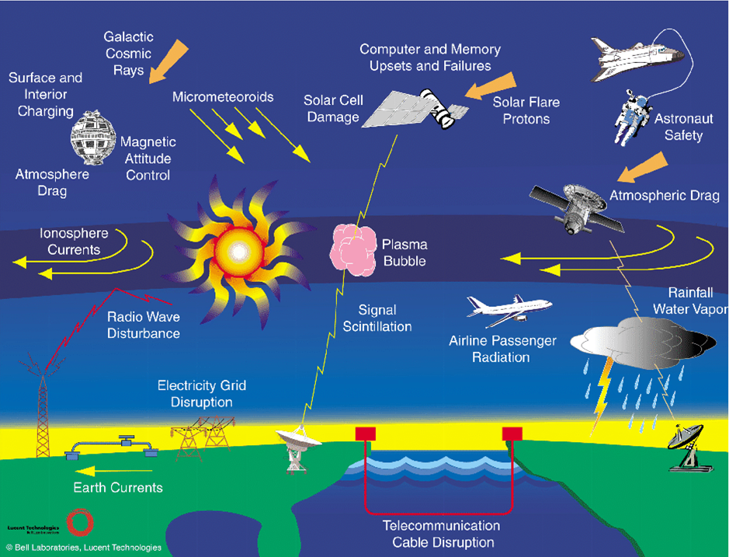
In order to make reliable predictions or warnings with the maximum lead time, it is necessary to start at the source of the disturbances, the sun. A single event, may be spread over 2-3 days; the radiation effects occur almost immediately, the particle effects occur over hours to days, and the magnetic effects are delayed by 2-3 days from the start of the event. One or more of the ingredients, radiation, particles, or magnetic clouds, may be deceptively weak while another reaches dangerous proportions, and only through long experience can one hope to recognize the signs of a developing threat in time for a meaningful warning.
Necessary strategies for reducing the impact of these effects should rely chiefly on early warning, or prediction of impending events, so that satellites can avoid risky maneuvers, astronauts can seek safety, polar flights can be rerouted, and communications can shift to more “hardened” lines of communication. Equally important is the need for commanders to know that communication difficulties they may experience are the result of natural effects, and not the actions of an adversary. Another mitigation strategy is to use the knowledge gained in space weather studies to the design of satellite systems so that they will survive the largest event expected over their design lifetime.

At present, much of the efforts rely on detecting such events when they reach near-Earth satellites, like ACE, and the data are used to estimate the length of the event. The sun is monitored for space weather storms, but not at all times and with measurements needed to detect solar storms.

At Big Bear Solar Observatory (BBSO), we have unique experience and capabilities to actually forecast the terrestrial impact of such events, hours to days before they reach Earth:
A) From BBSO, we have been monitoring some kinds of the events for many years with a global network of telescope requiring operators and issuing space weather storm warnings when appropriate. Therefore we can even predict the solar eruption a few days before they occur.
B) We have now designed and deployed robotic telescopes to make cost effective measurements of climate.
C) We have written and tested software for flare detection, and other solar eruptions. The software uses neural networking in the frame of Supporting Vector Machine, and learns how to detect flares from a sample input.

We propose to build a global network of robotic telescopes to monitor the sun and release automated real-time reports of significant eruptions with near real-time interpretation. This would be vastly less expensive and more capable replacement of the long dated Air Force SOON system. With our long experience in forecasting coupled with our experience in building robotic telescopes, operating global networks and with the addition of state of the art artificial intelligence detection software, BBSO is uniquely positioned to fill this essential niche.

The Solar Storm Monitor (SSM) prototype will cost $800 K, and $600 K for each clone. The goal is to deploy a fully operational three station network in three years costing $2.0 M with three more stations over the following two years to have redundant coverage in case of cloudy weather or hardware problems at one station. The SSMs can be sited at solar observatories chosen for image quality, rather than military bases chosen because there are personnel. The operating costs will be about $200 K per year, all of which is an order magnitude less expensive than the proposed ISOON. The SSM is described in more technical detail in the next section.

Solar Storm Monitor:

We propose to build and deploy a global network of near-robotic, synoptic telescopes that will provide a thorough spectrum of real-time, full-disk images of the Sun, which are essential in studies of space weather. These telescopes will be simple, inexpensive and made from off-the-shelf items. In baseline operation, one-arcsecond pixel resolution images will be in Hα every minute. Cadences would automatically increase in the event of a flare or filament eruption. Further, the SSM (Solar Storm Monitor) telescopes would provide vector magnetograms every few minutes. The magnetograph provides white light images with the same cadence. As well, full disk CaK images will be available with this cadence. Each kind of measurement provides unique and essential information on solar events that drive space weather. Hα is essential in tracking of filaments and flares, while the vector magnetograms elucidate the structure of active regions. All of these data will be made easily available in near real-time.

BBSO is the ideal site for the SSM prototype. In the National Solar Observatory (NSO) site survey for the next generation national solar telescope, the seeing (r₀, a measure of the largest aperture telescope that would be diffraction limited at that site) vs. time of day is shown in the figure below for the three finalists.
The black line is for BBSO and the other two lines are for the Halekala (red) and LaPalma (blue), as measured by NSO’s dual image motion monitor. BBSO is characterized by steady good seeing all day long most every day over the two years of site survey data. This makes BBSO the ideal U.S. site for collecting space weather, synoptic data. The data also justify a high resolution solar telescope in BBSO.

In an era when high resolution telescopes, like BBSO’s 1.6 m off-axis telescope (the NST with a hardware cost of about $4.5 M), are coming to fruition, it is critical to have high quality full-disk synoptic data to provide context for the high resolution data, especially in predicting space weather and probing its origin. The SSM system is made necessary at BBSO because the NST will supplant all of the current telescopes, and new and upgraded synoptic system will enable the NST to reach its potential.

BBSO has been operating a global Hα network for several years. This includes developing all the image processing and automatic filament eruption detecting software. In addition, we have built a semi-robotic synoptic telescope for observing earthshine to measure the Earth’s albedo; a clone of the prototype about to be deployed in the Canaries. Semi-robotic means manual operation to open and close, but all other aspects are fully robotic. We have found that this type of semi-robotic telescope minimizes complications in design and problems of cost. Finally, hardware choices were made based on our experience in designing and building Hα telescopes and digital vector magnetographs. We need and can build requisite sub-arcsecond resolution with inexpensive, reliable and automated hardware. The SSM will be constructed with all off-the-shelf items, as were the semi-robotic earthshine telescopes.

BBSO has long experience in providing synoptic data products to the solar community and beyond. These data are used by us, and others to provide near real-time space weather forecasts. As well, BBSO synoptic data have been used by many in basic research projects around the world, such as many Ph.D. theses.

The prototype SSM will be based on our long experience in building synoptic telescopes and semi-robotic telescopes for our global networks. All components of the each SSM are easily repaired/replaced because they are commercially available and will utilize control and analysis software that we developed and is fully operational in our existing synoptic systems. Until recently, one essential component of the prototype was not commercially available, and that is the turret system. The turret is a copy of the new and successful Swedish Solar Telescope (SST) – at present, the world’s most capable telescope for high-resolution studies of the Sun. Stockholm’s Digitalmekanik, the manufacturer of the SST, is marketing a miniature, cost-efficient version of the SST with an aperture of 25 cm, which is ideally suited for a synoptic telescope like the SSM. The SSM would be fed by light from an evacuated turret system (see figure) elevated 5 m above the ground to ensure the highest quality light signal. The evacuated turret would reach vertically above the ground layer seeing. A system of flip mirrors, based on currently operating ones at BBSO, would alternatively direct the light exiting the turret to full-disk Hα, Vector Magnetograph and CaK systems. This prototype would provide state of the art measures of the fundamental indicators of space weather changes.

The SSM Prototype:

Goal: Design, build and test a Solar Storm Monitor (SSM) prototype at BBSO to demonstrate its utility, practicality and robustness. It will be a semi-robotic telescope system, which only requires personnel to open and close. The full prototype would be fed by light from a commercially available evacuated turret system to ensure the highest quality light signal. The turret would reach above much of the boundary layer and be further improved by a commercially available tip/tilt system, which is the first order adaptive correction. The 25 cm aperture of the turret system would be stopped down to 15 cm, which about twice the Fried parameter, r₀, of the BBSO at the height of the turret. The diffraction limit of the stopped down system is about 0.7 arcseconds. The stop-down is made to enable us to make full disk H and magnetograms with the BBSO Lyot filters. With large Fabry-Perot filters, it would be possible to take full advantage of the 25 cm aperture (0.4 arcsecond diffraction limit). However, this is probably overkill (better spatial resolution than is currently available for any synoptic system) for space weather work, and would make the system much more expensive. If one wants much higher resolution, one should think of telescopes like the NST, which have to sacrifice field-of-view for resolution because of thermal issues.

BBSO will provide all the required filters for the prototype, including the Hα and magnetograph Lyot filters, which the observatory has on-hand, and filters are not included in the cost estimate. Further, BBSO will provide the control computer and all our fully operational analysis software to provide one (processed) Hα image every minute with automatic flare/filament eruption detection software that can automatically make cadence five times faster. The images from this nearly robotic system will be provided to customers in real-time. The prototype budget is below.

Budget
Insulated Shipping Container with Power&AC (SSM Shelter) | $10 K
Support Structure (Concrete Foundation, Reinforcements, etc) | $20 K
25 cm TelescopeTurret System | $150 K
Tracking System | $10 K
Optics and Flip Mirrors | $40 K
Large Format (2K by 2K) Fast Camera | $50 K
Magnetograph Optical Components | $20 K
Tip/tilt System | $20 K
Optical Support Components | $20 K
Data Archive System Updated in Near-Real Time | $20 K
Three Person Years Labor including SSM design (Loaded Salaries) | $440 K
SSM Prototype Budget | $800 K

SSM Clones:

After successful testing and operation of the SSM prototype, BBSO would manufacture multiple versions of the turret system, and then deploy and install them around the world. The Canaries and Learmonth would be initial targets so as to give uniform global coverage at excellent sites with extended periods of clear skies and experienced observing teams. BBSO would also provide the optical feed to on-site Lyot (or Fabry-Perot) filters and camera systems. BBSO would also maintain the SSM’s, and work to ensure that the information is supplied to customers in a useful format in near real-time. Further, BBSO would collaborate with customers in the interpretation of the data.

