Technical Overview
The Open Telescope Of Big Bear Solar Observatory (OTBBSO)

Main specifications of the telescope
- 1.5 m aperture, direct pointing
- Gregorian configuration (three mirrors) with cooling systems
▲Open telescope tube, fully retractable dome
▲Ait-Az mount
▲Automatic pointing & tracking with Sun guide
▲Adaptive optics
- Focus redirectable into three the instrument of plane
▲3 arcmin field of view
▲62m effective focal length. The final ratio f/41.3
▲Wavelength range from 0.3-1.7u
▲High resolution: 0.1arcsec (0.1 arcsec with adaptive optics)
▲Observing moon in night is available
▲Many points monitor temperature for the telescope
▲Primary mirror: Zerodur; parabplic mirror
- Second & third mirror: Silicon carbide (SiC), elipse mirror
▲Adaptive optics systems
NOTE: This design is utilizing the base and building of BBSO’s 65 CM telescope

Instruments
★the visible Fabry-perot spectrometer.
★the infrared Fabry-perot spectrometer.
★high resolution spectrograph.

Open telescope and dome
In addition to the atmospheric effects, solar telescopes suffer from heating by sunlight of the optics and the air within the telescope. This causes the image to shiver and become blurred. Modern solar telescope are either vacuum telescope, filled with helium or use careful control of the optic’s temperature to reduce heating of the air in telescope.
Vacuum telescope cannot be built with large apertures because such a design requires a vacuum window of extremely high optical quality, one that is as large as its aperture. It is then the first optical component in the telescope and has to be polished to high optical quality. This is difficult because of the thickness needed to withstand the enormous difference in pressure between the air and the inside of vacuum window. So we think it is difficult to design the vacuum of telescope, if the aperture is more large than 1 meter.
OPBBSO is designed as a completely open telescope with a retractable dome, to avoid internal seeing. This design allows for a stiff construction. Care will to be taken to protect the telescope from dust and withstand from strong wind.
If we want to operate the open telescope very well, key point is keeping the temperature of mirror as same high as the air , then there is not swift between the surface of mirror and the air .We design a careful cooling system for the purpose, the temperature controlled accuracy is ± 0.1℃.
The layout of open telescope and retractable dome as show below:

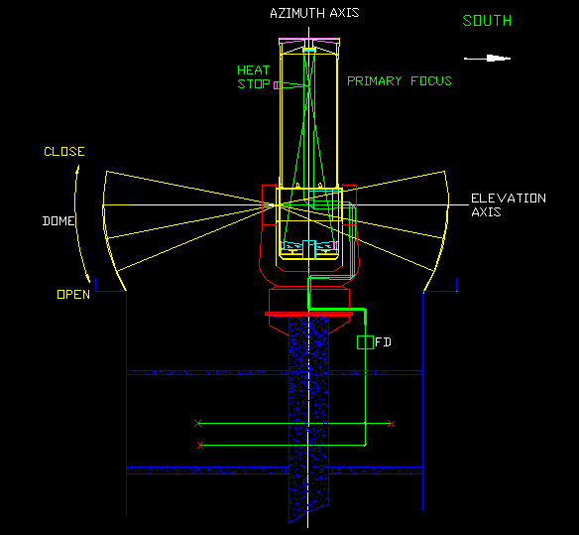

There are two key points for large diameter open solar telescope, one is keeping the temperature of mirror as same high as air, two is polishing high optical quality. Keeping the temperature of mirror means with temperature controlled optics, we use four high-precision cooling systems for M1,M2,M3,M4, the cooling systems will absorb heating from mirrors and carry away, other three delicate cooling systems will absorb heating from heat stop, circle, four-vanes and carry away.

Optics
The telescope uses a two mirrors Gregorian configuration with an f/3.2 primary mirror (M1), the shape of mirror is a parabolic mirror. A tilted cooled head stop mirror (M2) at the primary focus reject the 98% light out to heat stop except a hole 3 arc min in diameter, this is enlarged by an ellipsoidal second mirror (M3) and reflected out of the axis by a flat mirror (M4). The mirror (M5), mirror (M6) and mirror (M7) in fork , there are rotation with azimuth axis, there reflect image to M8 along azimuth axis,
We adopt this design because there is not hole in the base of 65cm telescope of BBSO. The mirror (M8) and mirror (M9) reflect image in FD. In focal plane, we can use another optic systems for the purpose.
The layout of optics as show below

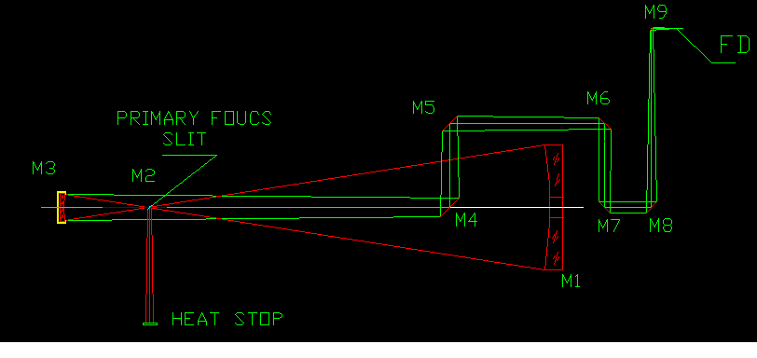
The primary F-RATIO=3.2
The effective focal length = 62M
The final ratio f/42
Focal resolution =1’’/0.3mm
Exit pupil diameter = 285 mm, position is located 1200mm behind second mirror
In order to obtain the high resolution of telescope, optics will be arrived diffraction limited, so the primary mirror M1,the second mirror M3, and flat mirror (M4,M5,M6,M7,M8,M9), the polished accuracy RMS is λ/20.

Mechanical structure
We uses Ail –Az mount for the 1.5M telescope, because the Ail-Az type telescope has the lightweight and balance, total weight is 5 T. Main problem for this telescope is stiffness, and deformation by temperature change. We consider this problem seriously, use indium in some key parts in the telescope, and adapted equivalent distortion technology, the tube absolute distortion is less than 10 micron. Also we use cooling systems to maintain some parts which face to the sun as same others, when telescope observe.

Control system
We uses PC industrial controlled computer to control the telescope with LINUX operated system.
Uses DC motor to drive the telescope and sun guider for tracing, the absolute encoder be adapted in the systems for high pointing , in this case the telescope also can be used for other propositions.
The dome moving with telescope simultaneously. There are four high-precision temperature controlled systems for three mirrors (M1,M2,M3,M4), temperature control accuracy is ±0.1 ℃. There are three delicate temperature control systems for others components of telescope which needs to reduce effect by temperature, temperature control accuracy is ±0.3 ℃. More sixty the temperature monitor points will be needed in the telescope to estimate the performance by temperature change. Main control computer can exchange date with serial or parallel ports.
Moving range: AZ axis ± 180° (south is origin)
El axis +10°to +80°
Speed range: AZ axis 1”/sec to 1°/sec
EL axis 1”/sec to 1°/sec
Pointing accuracy: 5”
Tracing accuracy: 1”/5 min (without sun guiding)
1”/10 Min (with sun guiding)

The plan and program of the telescope

The detail process of the telescope as show as below the table, we will spent three years to complete this the project, if we start to work for the telescope in the beginning of 2003, will finishing by end of 2005. We will design, manufacture, assembly and test the telescope for two year and half in China in early days, late we will assembly and test the telescope in U.S.A. for half year.

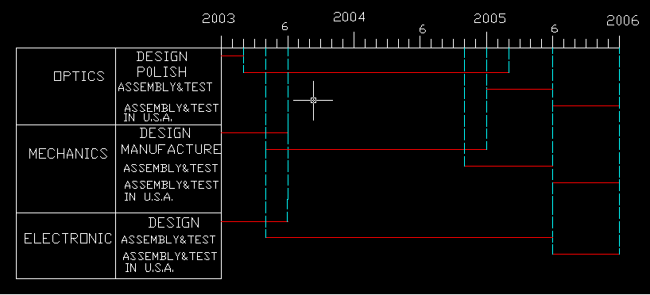

Total fee: $1,278,000

This number is rough estimate, we will calculate the fee carefully when we go bake to China, then giving a exactly quoted price.

